Silesian University of Technology

Hierarchical Control Lab-6

Title of the exercise:

“Dynamic programming”

Date of the exercise:
06.12.2013

Group Students:
Ismail Kalay
Aiganym Kadrina

Introduction:
During the laboratory students perform sensitivity analysis for complex static non-linear models.
Sensitivity coefficients (partial derivatives) are generated using both: sensitivity model and the
adjoint system. The obtained gradient is used during minimum searching for analyzed non-linear
function.
Students are supposed to know how to construct:
--sensitivity model,
-- adjoint system
for any non-linear static system given in a structural form (as a block diagram). Furthermore, basic
knowledge about gradient optimization methods will be required.

Task 1: Show the plot (contour plot or 3D plot) of given non-linear scalar function of two arguments.

a=7;b=a^2;
[x,y] = meshgrid(-10:.1:10, -100:.1:100);
f=(x-a).^2+b.*(y-x.^2).^2;
figure (1)
mesh(x,y,f)
xlabel('x')
ylabel('y')
zlabel('f(x,y)')

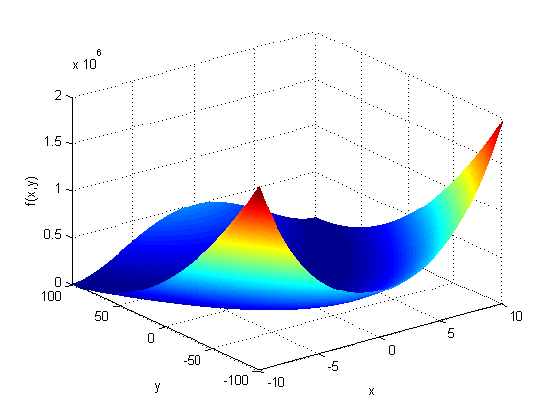

Task 2: Present given function in the structural form

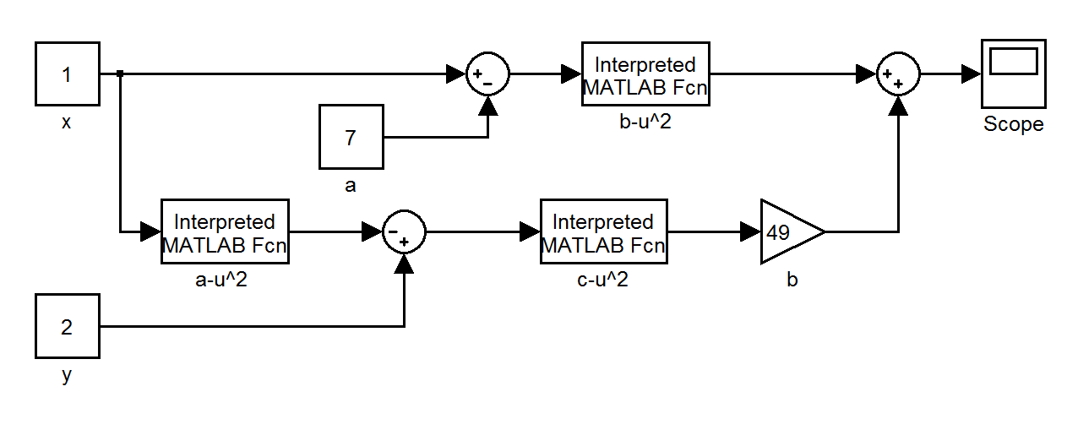

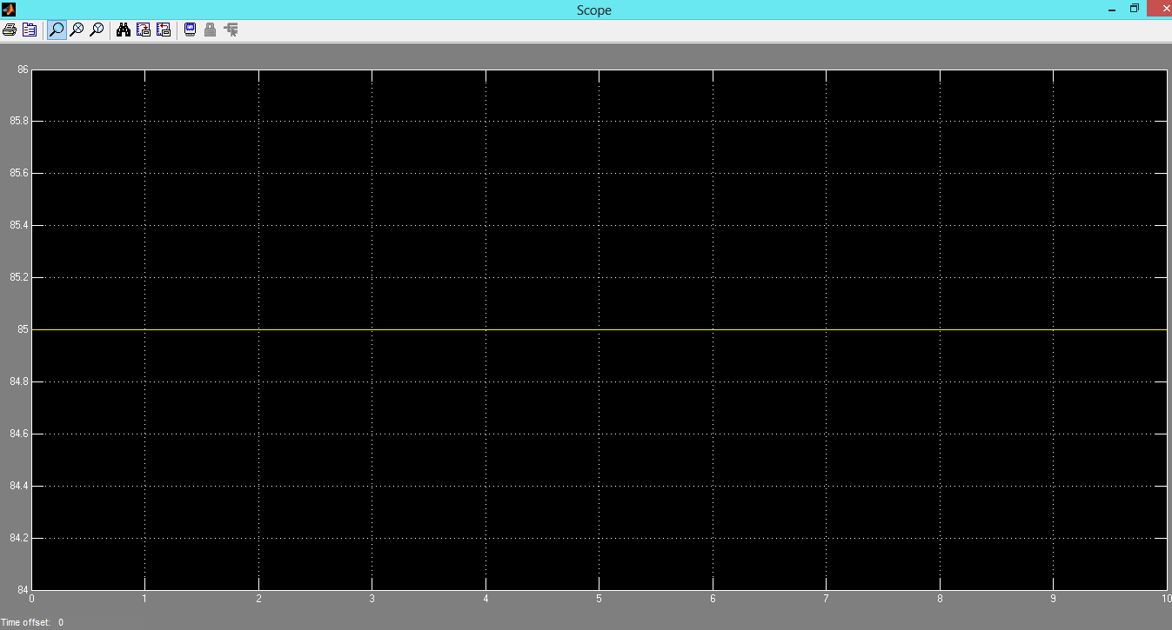

Task 3: Construct the sensitivity models (one model for each argument.

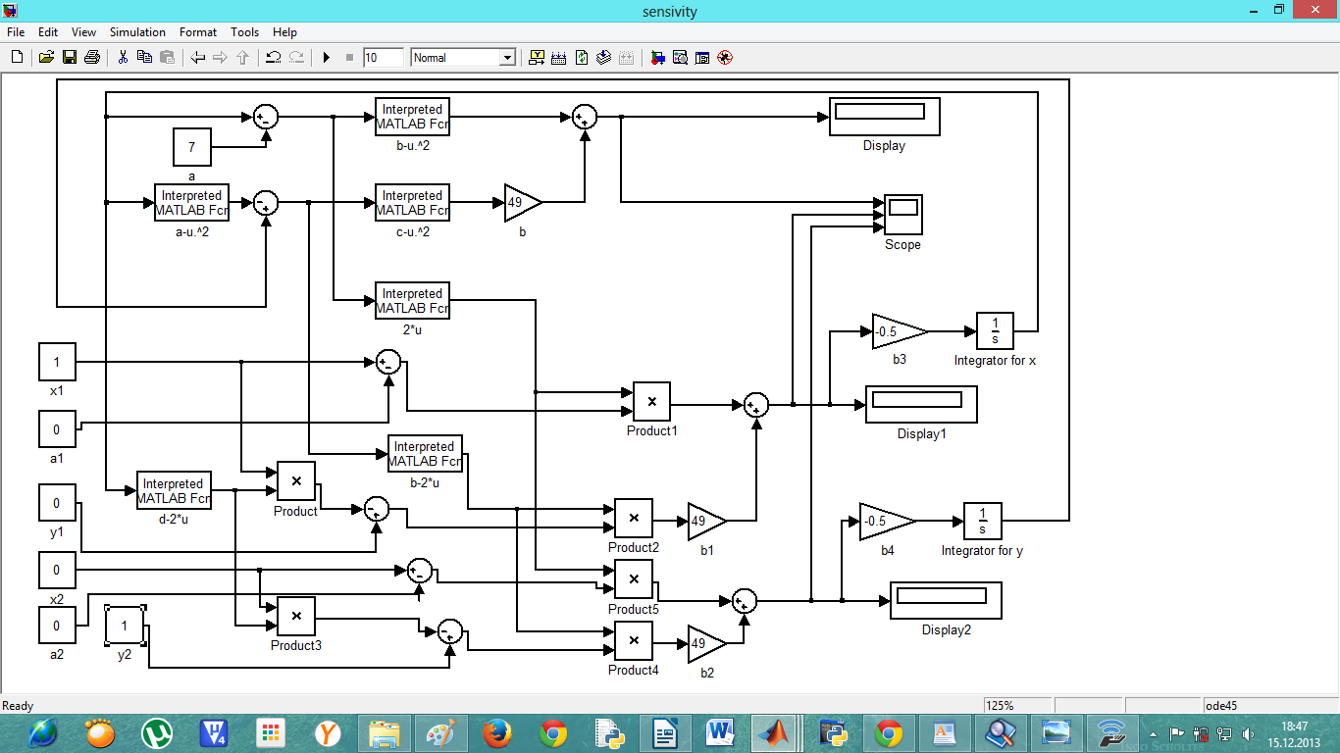
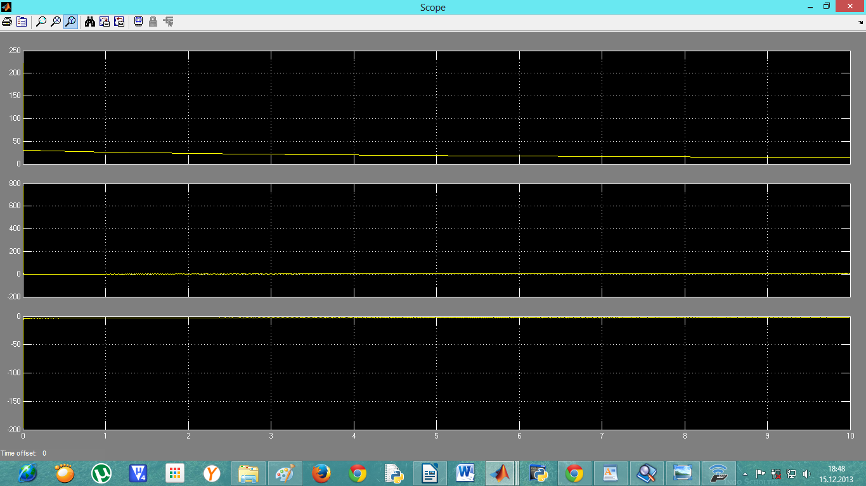

Task 4: Construct the adjoint model .

